Gasoline-Price Inflation and Grocery Price Changes:
A Comparison of Perishable and Nonperishable Food Categories in the United States, 2019–2025
Selena Long

Abstract
Consumer prices change for a lot of reasons, like gas prices, supply-chain problems, and inflation. For this project, I looked at whether gas prices were connected to grocery prices from 2019 to 2025. I also wanted to see whether perishable foods were affected more than nonperishable foods because they usually need faster and refrigerated transportation. The data included gasoline and six food groups: meat and eggs, dairy, fruits and vegetables, cereals and bakery products, nonalcoholic beverages, and sweets and candy. The food data was missing October 2025, so I estimated that month using the months before and after it.
I used two different forecasting methods. One SARIMA model was made for each category, while one VAR model looked at all the categories together. I left out the last 12 months so I could test how well the models worked on data they had not already seen. I compared the models using MAE, RMSE, MAPE, and SMAPE. I also used correlation, Granger-causality tests, and impulse-response functions to check whether changes in gas prices were followed by changes in food prices.
The results did not show a strong connection between gas prices and grocery prices. Most food categories had almost no relationship with monthly gas-price changes, and gas-price shocks barely changed food prices. Meat and eggs were the main exception because gas prices helped predict changes in that category. The VAR model did better for gasoline, dairy, fruits and vegetables, and nonalcoholic beverages. The SARIMA models did better for meat and eggs, cereals and bakery products, and sweets and candy. Based on these results, gas inflation did not have a large effect on grocery prices, although perishable foods may have been affected a little more.

1. Introduction

1.1 Background
The Consumer Price Index (CPI) tracks how the prices people pay for goods and services change over time. Gas and groceries are two costs that most families notice, and both are measured each month. Gas prices can change quickly because of oil prices, refinery problems, and supply shortages. Grocery prices usually change more slowly, but food still has to be transported, refrigerated, and stocked. Because of that, this study examines how gasoline price inflation affects price changes in perishable compared with nonperishable grocery categories in the United States from 2019–2025.
The study uses gasoline data and six food categories. The perishable categories are meat and eggs, dairy, and fruits and vegetables because they spoil faster and often need refrigerated delivery. The nonperishable categories are cereals and bakery products, nonalcoholic beverages, and sweets and candy because they can usually be stored longer. Cereals and bakery products are not completely nonperishable because the category includes both cereal and fresh bread, so this is included as a limitation. Since the data is recorded by month and earlier months may affect later months, time-series methods were used.

1.2 Research Problem
How does gasoline-price inflation affect price changes in perishable compared to nonperishable grocery categories in the United States from 2019–2025? This study also compares individual forecasting models with a multivariate model to better understand these relationships.

1.3 Research Questions
1. How did gasoline CPI and grocery CPI change from 2019 to 2025?
2. Were monthly changes in gasoline CPI related to monthly changes in grocery CPI?
3. Did gasoline CPI help predict later changes in grocery CPI?
4. Were perishable food categories more affected by gasoline changes than nonperishable food categories?

1.4 Hypotheses
1. Changes in gasoline CPI will be related to changes in grocery CPI.
2. Perishable food categories will respond more strongly to gasoline changes than nonperishable food categories because they require more frequent refrigerated transportation.
Null Hypothesis: Changes in gasoline CPI will not have a meaningful relationship with grocery CPI, and perishable categories will not respond more strongly than nonperishable categories.

2. Significance of the Study
Gasoline and food inflation can affect household budgets, food prices, transportation costs, and business decisions. Looking at whether gas prices are connected to grocery prices can help explain whether one type of inflation leads to another. This study is useful because it tests the common idea that higher fuel costs cause grocery prices to rise. It also tests the forecasting models on data that was not used to build them, which gives a more fair comparison of how accurate they are.

3. Dataset

3.1 Data Source
The data came from the U.S. Bureau of Labor Statistics. I used monthly CPI-U data for the U.S. city average, and the values were not seasonally adjusted.
Dataset source: U.S. Bureau of Labor Statistics Consumer Price Index
Database: BLS CPI database
Series used:
Gasoline, all types: CUUR0000SETB01
Meats, poultry, fish, and eggs: CUUR0000SAF112
Dairy and related products: CUUR0000SEFJ
Fruits and vegetables: CUUR0000SAF113
Cereals and bakery products: CUUR0000SAF111
Nonalcoholic beverages and beverage materials: CUUR0000SAF114
Sugar and sweets: CUUR0000SEFR
Access date: July 18, 2026
Source location: BLS CPI Data Viewer and public data files
Date range: January 2019 to December 2025
Frequency: Monthly
Number of observations: 84 months

3.2 Variables
Variable | Description
Month and year | Monthly observation date (Jan-19 format)
Gasoline CPI | CPI for gasoline (all types)
Meat and Eggs CPI | CPI for meat, poultry, fish, and eggs
Dairy CPI | CPI for dairy and related products
Fruits and Vegetables CPI | CPI for fruits and vegetables
Cereals and Bakery CPI | CPI for cereals and bakery products
Nonalcoholic Beverages CPI | CPI for nonalcoholic beverages
Sweets and Candy CPI | CPI for sugar, sweets, and candy

4. Data Preparation

4.1 Date and Numeric Conversion
The month-and-year column, such as Jan-19, was changed into a standard monthly date and placed in order. All CPI values were converted into numbers, and any n/a entries were counted as missing data.

4.2 Missing Data
Gasoline had no missing values. Each of the six food categories was missing only the October 2025 observation. These isolated gaps were filled using time-based interpolation between the surrounding months. The interpolated values are estimates, not original observations, and are listed below.
Variable | Missing month | Imputed value
Meat and Eggs CPI | October 2025 | 347.995
Dairy CPI | October 2025 | 269.079
Fruits and Vegetables CPI | October 2025 | 356.110
Cereals and Bakery CPI | October 2025 | 361.727
Nonalcoholic Beverages CPI | October 2025 | 232.323
Sweets and Candy CPI | October 2025 | 309.837

4.3 Training and Testing Periods
- Training period: January 2019 through December 2024 (72 months)
- Testing period: January 2025 through December 2025 (12 months)
- Test-period length: 12 months
The models were fitted only on the training period, and the final 12 months were withheld to evaluate forecasting accuracy. This prevents a model from being judged on the same data used to build it.

5. Exploratory Data Analysis

5.1 Descriptive Statistics
CPI category | Mean | SD | Minimum | Median | Maximum
Gasoline | 274.94 | 50.72 | 160.26 | 282.00 | 409.67
Meat and Eggs | 300.35 | 33.18 | 248.21 | 316.08 | 348.20
Dairy | 249.54 | 21.51 | 216.47 | 263.45 | 272.84
Fruits and Vegetables | 331.26 | 22.23 | 298.14 | 341.78 | 357.72
Cereals and Bakery | 320.71 | 35.25 | 275.44 | 328.75 | 363.72
Nonalcoholic Beverages | 199.53 | 21.89 | 170.23 | 203.25 | 234.18
Sweets and Candy | 259.47 | 31.26 | 217.50 | 257.80 | 314.88

Gasoline had the largest variation over the study period, with a standard deviation of 50.72 and values ranging from about 160 to 410. The food categories changed much less. Dairy and nonalcoholic beverages had the smallest variation, while meat and eggs and cereals and bakery products showed slightly larger changes.

5.2 Trend Analysis
All categories increased between January 2019 and December 2025, but by different amounts. Sweets and candy increased the most (about 45%), followed by meat and eggs (39%) and nonalcoholic beverages (37%). Gasoline increased by about 36%, but its prices changed much more from month to month. Gasoline dropped sharply in early 2020 before rising quickly during 2021 and 2022, while most food categories showed steadier upward trends.

5.3 Relationship Between Gasoline and Grocery Changes
Monthly percentage changes in gasoline prices were compared with changes in each food category, and the correlations were weak and mostly slightly negative, showing that gasoline and grocery prices did not usually move together from one month to the next. The average correlation was about -0.07 for perishable foods and -0.16 for nonperishable foods, so gasoline price changes were not a strong predictor of grocery price changes during this period.

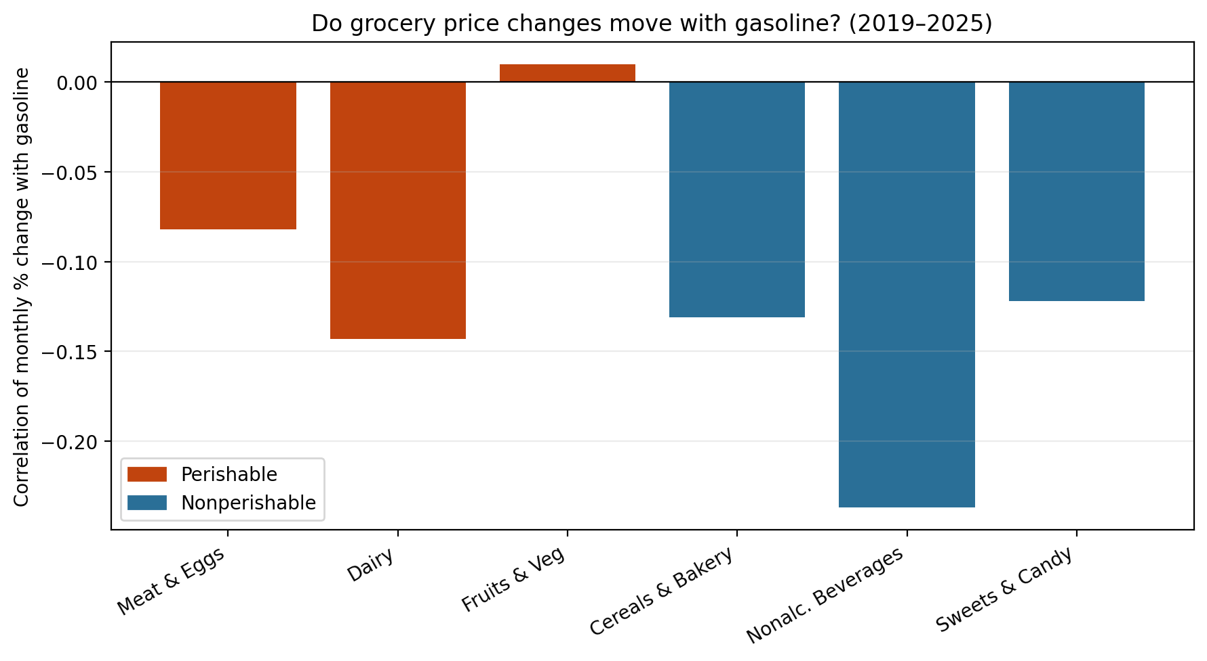
Figure 1. Correlation of each grocery category’s monthly percent change with gasoline’s, 2019–2025. Bars are near zero, showing weak co-movement.
Category | Group | Correlation with gasoline
Meat and Eggs | Perishable | −0.08
Dairy | Perishable | −0.14
Fruits and Vegetables | Perishable | +0.01
Cereals and Bakery | Nonperishable | −0.13
Nonalcoholic Beverages | Nonperishable | −0.24
Sweets and Candy | Nonperishable | −0.12

6. Time-Series Methods

6.1 Stationarity
An Augmented Dickey-Fuller (ADF) test was used to check whether each time series was stationary. Before differencing, all of the categories were nonstationary because they showed clear upward trends over time. After taking the first difference, gasoline, meat and eggs, fruits and vegetables, nonalcoholic beverages, and sweets and candy became stationary (all p-values below 0.01). Dairy (p ≈ 0.10) and cereals and bakery (p ≈ 0.15) were still close to the cutoff, so first-differenced data were used for the multivariate model.

6.2 Individual SARIMA Models
A separate SARIMA model was fit for each CPI category. Different model orders were tested, and the model with the lowest Akaike Information Criterion (AIC) was chosen for each category. Table X shows the selected model orders along with their AIC and BIC values.

CPI category | Order | Seasonal order | AIC | BIC
Gasoline | (0,1,2) | (0,0,1,12) | 467.13 | 477.25
Meat and Eggs | (0,1,2) | (1,0,1,12) | 272.56 | 284.72
Dairy | (1,1,1) | (1,0,1,12) | 217.82 | 230.08
Fruits and Vegetables | (0,1,2) | (0,0,1,12) | 215.85 | 225.98
Cereals and Bakery | (1,1,2) | (1,0,1,12) | 217.51 | 231.69
Nonalcoholic Beverages | (1,1,2) | (0,0,1,12) | 172.66 | 184.82
Sweets and Candy | (0,1,2) | (0,0,1,12) | 221.60 | 231.73

6.3 Multivariate VAR Model
A Vector Autoregression (VAR) model was used to analyze all seven categories together. This allowed each category to be affected by its own past values and the past values of the other categories, including gasoline. The model used first-differenced data, and the predicted changes were added back to get CPI levels. AIC selected 3 lags, although the other tests suggested fewer lags, which is discussed as a limitation.

6.4 Granger Causality and Impulse Responses
Granger-causality tests were used to see whether past gasoline changes helped predict later changes in each food category. Impulse-response functions were also used to show how each food category reacted after a sudden change in gasoline over the following months.

7. Model Evaluation

7.1 Performance Measures
The forecasts were tested on 12 months of data using four error measures. Lower error values meant the forecasts were more accurate.
MAE = (1/n) Σ |yₜ − ŷₜ|
RMSE = √[ (1/n) Σ (yₜ − ŷₜ)² ]
MAPE = (100/n) Σ |(yₜ − ŷₜ) / yₜ|
SMAPE = (100/n) Σ [ 2|yₜ − ŷₜ| / (|yₜ| + |ŷₜ|) ]

7.2 Fair Comparison
Both models were scored on the same 12 test months, so their errors are directly comparable. In-sample AIC values are not compared between SARIMA and VAR because the two have very different structures; the out-of-sample test errors are the meaningful comparison.

8. Results

8.1 Trend and Relationship Results
Gasoline had the biggest price swings during the study period. Sweets and candy had the largest overall increase, while sweets and candy and cereals and bakery showed the steadiest upward trends. The biggest changes happened between 2020 and 2022, when gasoline prices dropped during the pandemic and then increased quickly afterward.
For the main research question, the Granger-causality test showed that gasoline only significantly helped predict meat and eggs (p = 0.006). None of the other food categories had a significant relationship with gasoline, including dairy (p = 0.10), fruits and vegetables (p = 0.17), cereals and bakery (p = 0.13), nonalcoholic beverages (p = 0.90), and sweets and candy (p = 0.13).
Category | Group | Granger p (gas→food) | Significant?
Meat and Eggs | Perishable | 0.006 | Yes
Dairy | Perishable | 0.098 | No
Fruits and Vegetables | Perishable | 0.174 | No
Cereals and Bakery | Nonperishable | 0.126 | No
Nonalcoholic Beverages | Nonperishable | 0.898 | No
Sweets and Candy | Nonperishable | 0.134 | No

The impulse-response results were similar. A gasoline shock caused only very small changes in the food categories over the next six months, with all responses staying below 0.1 index points. The average response was about -0.016 for the perishable group and +0.009 for the nonperishable group, showing little overall effect from gasoline price changes.
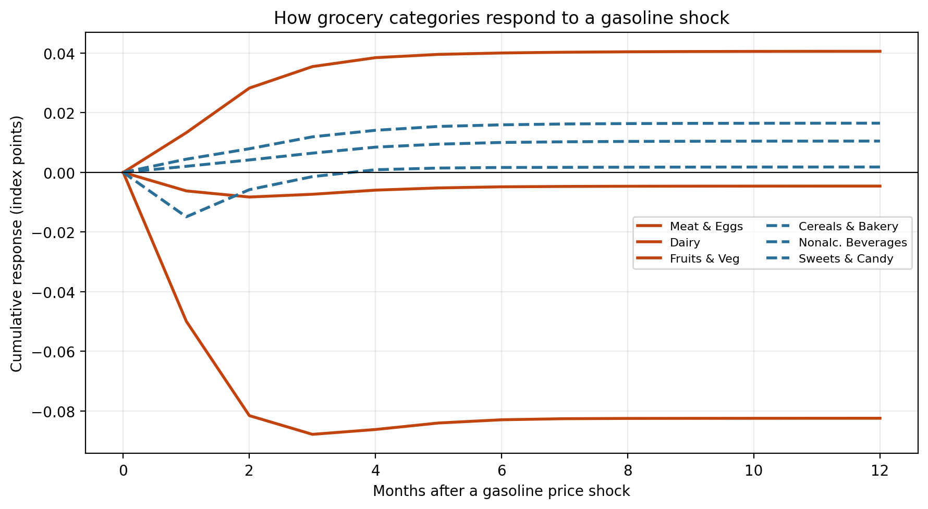
Figure 2. Cumulative response of each grocery category to a one-standard-deviation gasoline shock. All responses stay close to zero, showing that gasoline price shocks had very little effect on grocery prices.

8.2 Individual SARIMA Performance
CPI category | MAE | RMSE | MAPE (%) | SMAPE (%)
Gasoline | 28.65 | 31.41 | 10.40 | 9.78
Meat and Eggs | 2.72 | 3.56 | 0.79 | 0.79
Dairy | 3.98 | 5.29 | 1.48 | 1.46
Fruits and Vegetables | 8.94 | 9.50 | 2.53 | 2.49
Cereals and Bakery | 4.39 | 4.92 | 1.22 | 1.21
Nonalcoholic Beverages | 1.00 | 1.19 | 0.44 | 0.44
Sweets and Candy | 1.22 | 1.77 | 0.40 | 0.40

8.3 Multivariate VAR Performance
CPI category | MAE | RMSE | MAPE (%) | SMAPE (%)
Gasoline | 17.52 | 19.51 | 6.36 | 6.14
Meat and Eggs | 3.70 | 4.21 | 1.07 | 1.08
Dairy | 4.02 | 4.98 | 1.49 | 1.48
Fruits and Vegetables | 7.44 | 7.64 | 2.10 | 2.08
Cereals and Bakery | 5.59 | 6.07 | 1.55 | 1.54
Nonalcoholic Beverages | 0.71 | 0.81 | 0.31 | 0.31
Sweets and Candy | 3.94 | 4.23 | 1.29 | 1.30

8.4 Direct Comparison (by RMSE)
Category | Better model | SARIMA RMSE | VAR RMSE | Difference
Gasoline | VAR | 31.41 | 19.51 | 11.90
Meat and Eggs | SARIMA | 3.56 | 4.21 | 0.66
Dairy | VAR | 5.29 | 4.98 | 0.31
Fruits and Vegetables | VAR | 9.50 | 7.64 | 1.86
Cereals and Bakery | SARIMA | 4.92 | 6.07 | 1.15
Nonalcoholic Beverages | VAR | 1.19 | 0.81 | 0.38
Sweets and Candy | SARIMA | 1.77 | 4.23 | 2.47

Across all categories, the VAR model had a lower mean RMSE (6.78 vs 8.23), but that gap is driven almost entirely by gasoline; the median RMSE was nearly identical (4.98 vs 4.92). The VAR won for four categories (gasoline, dairy, fruits and vegetables, nonalcoholic beverages) and SARIMA won for three (meat and eggs, cereals and bakery, sweets and candy).

8.5 Findings Supported by Both Models
Both models showed similar results. Gasoline was the hardest category to predict and had much larger forecast errors than any of the food categories. Both models also captured the steady increase in food prices over time. Since two different methods reached similar conclusions, the results are more reliable and suggest that gasoline prices are only weakly connected to grocery prices.

9. Discussion

9.1 The Main Question: Limited Pass-Through
To answer the research question, gasoline-price inflation had only a small effect on grocery price changes between 2019 and 2025. Monthly connections were weak, and past gas price changes only helped predict later price changes for one of the six food categories. That category was meat and eggs, which was part of the perishable group. Gas price changes also caused only very small changes in the other food categories. Fuel is only one of many things that affect food prices. Farming, labor, packaging, transportation, and overall inflation also play important roles.

9.2 Perishable versus Nonperishable
Hypothesis 1 was only partly supported. Meat and eggs was the only category with a significant link to gasoline, and it was part of the perishable group. This could support the idea that foods needing frequent refrigerated transportation are more affected by fuel costs. However, the other two perishable categories did not show a significant relationship, and the average results for both groups were close to zero. Because of this, the difference between perishable and nonperishable foods was weak and mostly based on one category.
Meat and egg prices were also affected by avian influenza during this period, which caused large increases in egg prices. This means part of the relationship may have come from other events happening at the same time rather than gasoline alone.

9.3 Why Gasoline Is Hard to Forecast
Gasoline had the biggest forecast errors in both models. Its price can suddenly change because of oil prices, world events, refinery problems, or seasonal demand, so past data alone may not predict it well. Food prices usually changed more gradually, making them easier to forecast.

9.4 Individual versus Multivariate Forecasting
Neither model worked best for every category. VAR performed better for gasoline and some food categories, while SARIMA performed better for the others. This shows that using information from every category sometimes helped, but the past trends of a single category were enough in other cases.

10. Limitations
- The dataset contained only 84 monthly observations, which limits statistical power and can miss real but small effects.
- Only seven categories were analyzed; other drivers (oil prices, wages, interest rates, supply-chain indexes) were not included.
- CPI is an index, not a direct dollar price, and category definitions and seasonal adjustment should be confirmed from BLS.
- One food month (October 2025) was interpolated, producing estimated rather than observed values.
- The VAR lag was chosen by AIC (3 lags), but BIC and HQIC preferred fewer; with seven variables and 68 usable rows, the VAR is close to over-parameterized, so its detailed coefficients should be read cautiously.
- Granger causality and correlation show statistical association, not proven cause and effect.
- Forecast accuracy was judged on a single 12-month holdout period; results could differ in other periods.
- Structural breaks such as the pandemic and avian influenza may reduce model stability and confound category-specific results.

11. Future Research
Future studies could include other factors that affect food prices, such as crude oil prices, producer price indexes, transportation costs, or electricity prices. They could also compare the years before and after the pandemic separately or use a different way of testing forecast accuracy. Another idea would be to study fewer variables at a time or compare these models with machine learning methods.

12. Conclusion
This study looked at how gas price changes affected perishable and nonperishable grocery prices from 2019 to 2025. The results showed that gas prices had only a small effect on most food categories. Meat and eggs were the only category with a clear connection to gas prices. Perishable foods may have been affected a little more, but the difference between the two groups was still small. Overall, gas prices were not the main reason grocery prices changed.
The forecasting models also had mixed results. The VAR model worked better for some categories, while the SARIMA model worked better for others. Gasoline was the hardest category to predict because its prices changed more quickly and sharply. Overall, gasoline prices alone did not explain most grocery price changes. Other factors, such as farming costs, labor, packaging, supply problems, and overall inflation, also affected food prices.

13. References
U.S. Bureau of Labor Statistics. (2026). Consumer Price Index (CPI) databases and public data files.
U.S. Bureau of Labor Statistics. (2026). Consumer Price Index for All Urban Consumers: U.S. city average, by expenditure category.
pandas development team. (2026). pandas documentation.
statsmodels developers. (2026). statsmodels documentation.
Matplotlib development team. (2026). Matplotlib documentation.

